**Codingan**

**<https://github.com/Dini31/Tugas-1-Hacktiv>**

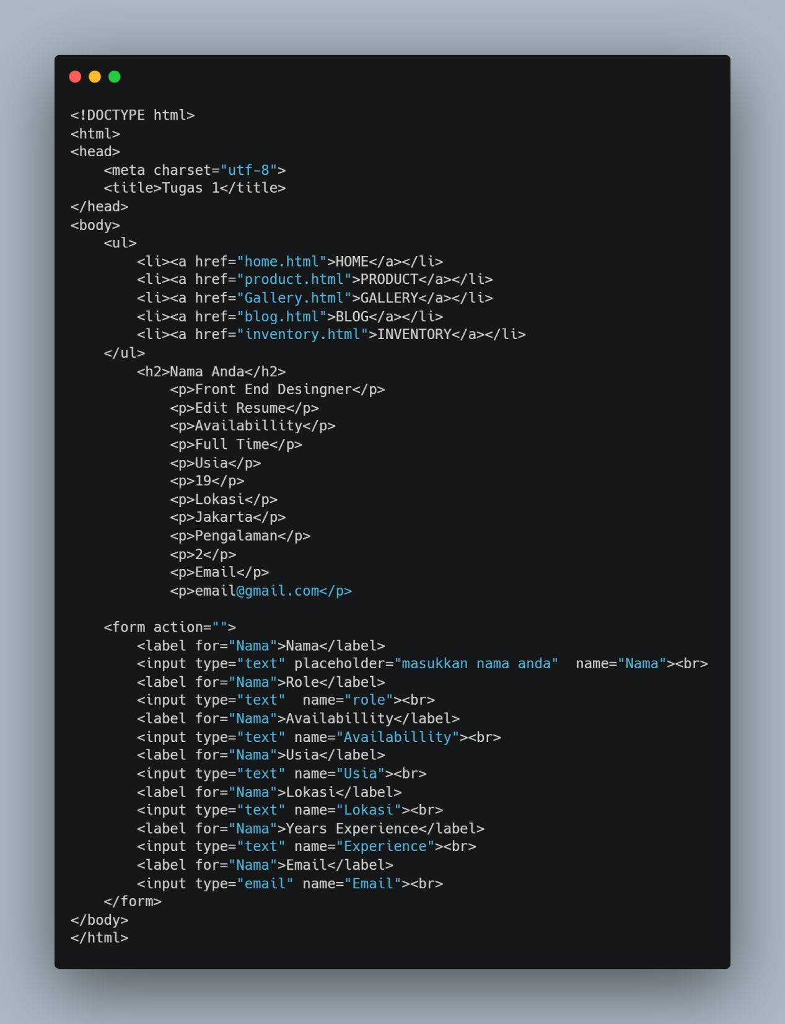

**Hasil**

